**ACKNOWLEDGEMENT**

First and foremost, we extend our sincere thanks to our our institution, **KVG College of Engineering** for providing me a platform to pursue my studies.

I have a great pleasure in expressing my deep sense of gratitude to our Principal, **Dr. Suresha V**, for their constant encouragement and support.

We are deeply grateful to the Head of the Department, **Dr. Savitha C K**, for providing us with the necessary resources.

We also wish to thank our faculty in charge, **Prof. Bhavya P S** for their dedicated efforts in overseeing the progress of this project and providing valuable inputs at every stage.

I consider it a privilege and honor to express my sincere gratitude to my guide **Prof.** **Venkatesh U C** , for the valuable guidance throughout the project.

I also extend my thanks to all the teaching and non teaching staffs who directly or indirectly encouraged me.

Finally, I would like to thank my parents and friends for all their moral support they have given me during the completion of this work.

**Abstract**

Road accidents are a leading cause of death and injury worldwide, requiring rapid detection and response to save lives. **The Automatic Crash Analyzer in Vehicle** aims to identify vehicular accidents in real-time using sensors and advanced machine learning techniques. The system integrates various technologies such as GPS, Arduino, LCD, GSM SIM800L, ADXL335, Engine, and onboard vehicle data to detect abnormal driving patterns and sudden impacts indicative of an accident. Upon detecting an accident, the system immediately triggers an alert, providing location details and accident severity to emergency services, significantly reducing response time.

The system can be deployed in both urban and rural areas, ensuring widespread safety coverage. It can also be integrated with vehicle infotainment systems, smart traffic management solutions, and smartphone applications, enhancing accessibility and usability. By employing artificial intelligence to distinguish between false positives and genuine incidents, the system aims to improve road safety and reduce fatalities through timely interventions.

**Table of Contents**

**Page No.**

**Certificate**

**Declaration**

**Abstract**

**Acknowledgement**

**Table of contents**

**List of Figures**

**1 INTRODUCTION**

**1.1 Relevance of the Project**

**1.1.1 Block Diagram**

**1.1.2 Agile Methodology**

**1.2 Scope of the Project**

**1.3 Objectives**

**1.4 Methodology**

**1.5 Problem Statements**

**1.6 Existing System**

**1.7 Proposed System**

**2 LITERATURE SURVEY**

**2.1 Research and Technical Papers**

**2.2 Comparison between Research Papers**

**3 SYSTEM ANALYSIS AND DESIGN**

**3.1 System Design**

**3.2 Flow Chart**

**3.3 Use Case Diagram**

**4 IMPLEMENTATION**

**4.1 Proposed Algorithm**

**4.2 Code used**

**5 RESULTS AND DISCUSSION**

**6 CONCLUSION AND FUTURE SCOPE**

**6.1 Conclusion**

**6.2 Contribution**

**6.3 Future scope**

**REFERENCES**

**LIST OF FIGURES**

**Figures Page No.**

**Fig:1 Block diagram of the circuit**

**Fig:2 System design**

**Fig:3 Flowchart**

**Fig:4 Use case diagram**

**Fig:5 Interfacing controller with all other module**

**Fig:6 Alert message**

**CHAPTER 1**

**INTRODUCTION**

Road traffic accidents are a significant concern worldwide, leading to loss of life, injuries, and economic damage. A critical issue contributing to these outcomes is the delay in reporting accidents and obtaining timely assistance. In many cases, the time required to alert emergency services plays a decisive role in determining the survival and recovery of accident victims. Despite advancements in vehicle safety technologies, the critical factor of delayed accident reporting continues to hinder timely medical intervention and assistance, leading to preventable outcomes.

In light of these challenges, this project introduces an innovative solution: the Automatic Crash Reporter in Vehicles. This system aims to redefine how accidents are detected and communicated, providing a seamless and immediate reporting mechanism that ensures help reaches the scene as quickly as possible. By automating the process, the system eliminates reliance on bystanders or manual reporting, reducing delays and enhancing the efficiency of emergency response.

With a vision of creating safer roads and more resilient communities, this project underscores the importance of integrating intelligent systems into modern vehicles. The Automatic Crash Reporter is not merely a technological advancement; it is a step toward saving lives and addressing one of the most pressing issues in transportation today.

The project focuses on developing a cost-effective and reliable solution that can be implemented in vehicles of various types. It also paves the way for further advancements in intelligent transportation systems, contributing to safer roadways and improved accident management.

* 1. **Relevance of the Project**
* The accidental detection and alert system are designed to detect the accidents and alert rescue team in time.
* Arduino is major control unit to communicate between devices when an accident occurs, which helps in transferring messages to different devices in the system.
* Receiving pin of GSM module and transmitting pin of GPS module are used to communication.
* GPS module will find the location of the vehicle and the information is fetched by the receiver through the coordinates and the received data is sent to Arduino and the alert to rescue team by GSM module.
* The accelerometer and adxl335 detect the accident occurrence by the reading produced by the movements of the vehicle.
* The vibration sensor is also used to detect the accident by producing voltage from the impact of vehicle movements
  + 1. **BLOCK DIAGRAM**

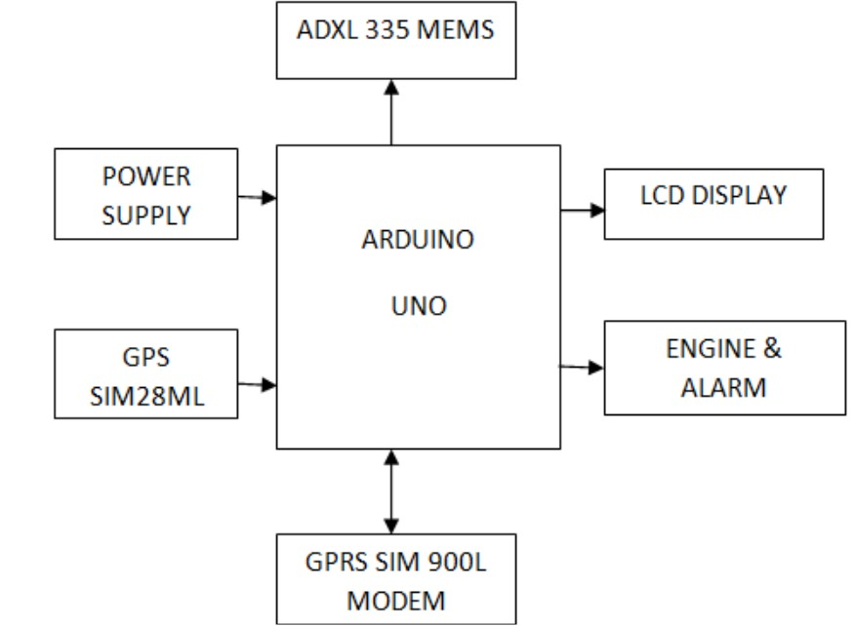

**Fig:1**

* + 1. **Agile methodology or summary of approaches**

|  |  |  |  |  |
| --- | --- | --- | --- | --- |
| **SI.NO** | **Task** | **Requirement** | **Approach/Technology** | **Output/Goal** |
| 1 | Predict Sudden Speed Drop | Detect rapid changes in speed | As a project developer we should design to detect the speed changes using Accelerometer | Identify potential incidents or emergency scenarios based on abrupt deceleration patterns |
| 2 | Confirm Accident | Validate whether a detected event is an accident | Switches and threshold-based decision logic | Accurately confirm accidents to avoid false alerts. |
| 3 | Retrieve GPS Coordinates | Get the location of the incident | GPS Module, Trilateration | |  | | --- | |  |  |  | | --- | | Provide precise location data for emergency reporting. | |
| 4 | Send SMS Notification | Notify nearby hospitals with GPS coordinates | GSM Module, Cellular Technology | Alert hospitals/emergency services with critical accident details. |

### 1.2 Scope of the project

The Automatic Crash Analyzer system is designed to:

* Detect collisions or sudden impacts in a vehicle.
* Send an emergency alert with location coordinates to predefined contacts or emergency services.
* Record crash data for analysis and future references.
  1. **Objectives**
* Design a system to detect vehicle accidents using accelerometers and other sensors.
* Automatically notify emergency services or predefined contacts via GSM in the event of an accident.
* Provide accurate real-time location data of the vehicle using GPS for swift emergency response.
* Reduce response time during accidents to potentially save lives.
  1. **Methodology**
* Connect Arduino with GSM, GPS, and accelerometer modules for hardware integration.
* Program Arduino to detect sudden impacts using accelerometer data.
* Trigger GPS to capture real-time location coordinates during an accident.
* Use GSM to send accident alerts with location details to emergency contacts.
* Test the system for accuracy and reliability under various scenarios.
  1. **Problem Statements**

• Road accidents often lead to delayed emergency responses due to a lack of real-time detection and reporting systems.  
• Current methods rely heavily on bystanders or manual reporting, which can result in significant time loss and a higher risk of fatalities.  
• This project aims to address these challenges by creating an automated system that detects accidents instantly and sends precise location data to rescue teams, enabling faster response times and potentially saving more lives.

**1.6 Existing System**

Traditional accident detection systems primarily depend on historical traffic data, including daily and hourly volumes, for predicting accident probabilities. In contrast, real-time systems gather data from devices such as induction loops, infrared detectors, and cameras to analyse traffic conditions before or after an accident occurs.

However, these systems face several challenges, such as limited sensor availability, budget constraints, inefficient algorithms, and environmental factors like weather and fluctuating traffic conditions, which reduce their effectiveness.

* 1. **Proposed System**
* The system will use an **accelerometer sensor** to detect sudden impacts or rollovers, identifying accidents in real time.
* A **GPS module** will track the vehicle’s exact location and provide accurate latitude and longitude details during an accident.
* A **GSM module** will automatically send emergency alerts, including location details, to predefined contacts or emergency service
* All components will be integrated with an **Arduino microcontroller** to handle data processing and communication.
* The system will be installed directly in the vehicle, ensuring it operates independently of external infrastructure like traffic sensors.
* Designed as a **cost-effective solution**, the system will function reliably under various conditions, including adverse weather or remote locations.
* The project aims to improve response times, reduce fatalities, and enhance road safety by providing timely accident reporting.

**CHAPTER 2**

**LITERATURE SURVEY**

**2.1 RESEARCH AND TECHNICAL PAPERS**

**2.1.1Accident Detection and Reporting System using GPS, GPRS and GSM Technology (@2012 IEEE):**

This paper proposes to utilize the capability of a GPS receiver to monitor the speed of a vehicle and detect an accident basing on the monitored speed and send the location and time of the accident from GPS data processed by a micro-Controller by using the GSM network to the Alert Service Centre.

Nowadays, GPS receiver has become an integral part of a vehicle. Besides using in other purposes, the GPS can also monitor the speed and detect an accident. It can use a very cheap and popular GSM modem to send the accident location to the Alert Service Centre. It can also send the last speed before accident which will helps to assess the severity of the accident and can initiate a voice call.

Beside the automatic detection system, the vehicle occupant will be able to manually send the accident situation by pressing the Manual Detection Switch. A rescue measures in time with sufficient preparation at the correct place can save many life. Thus, the proposed system can serve the humanity by a great deal as human life is valuable.

**2.1.2 Accident Reporting and Guidance System with automatic detection of the accident *(*@2016 IEEE)**

The main purpose of the system is to find the nearest medical unit from the accident location. This was achieved by using some features that the GPS receiver and Google Maps are providing. The server application together with the mobile one and the database compose the strongly connected client server applications system and there is no sense of using one part without the other one.

All the information that is coming from the mobile application is introduced in the database using a few php services and only after that the server can perform some actions based on the database tables. Most of the actions are performed in order to find some information or add a new one. If more records on a table like hospitals, then more chances for finding a favourable solution. If we talk about the People table, the number of records represents the number of users of the application.

The application is under development. In the future, the application will be implemented in IOS devices (for mobile terminals) and the accident detection module will be improved wit IA features.

Also, the accuracy of commercial GPS included in the mobile phones will be increase using Kaman filters.

**2.2 Comparison between Research Papers**

|  |  |  |  |
| --- | --- | --- | --- |
| **Aspect** | **Paper 1: Accident Detection and Reporting System using GPS, GPRS, and GSM Technology (2012)** | **Paper 2: Accident Reporting and Guidance System (2016)** | **Vehicle Accident Detection and Reporting System (2024)** |
| **Objective** | **Accident detection and reporting using GPS and GSM.** | **Accident detection, reporting, and guidance to the nearest medical facility.** | **Accident detection, reporting, and enhanced real-time notifications.** |
| **Technology Used** | **GPS, GSM, GPRS, Microcontroller.** | **GPS, Google Maps API, PHP services, database, and mobile application.** | **Arduino, GSM, GPS modules for real-time accident reporting and location sharing.** |
| **Data Processing** | **Microcontroller processes GPS data for speed and accident detection.** | **Server processes data collected via mobile application.** | **Arduino processes accident triggers and sends alerts through GSM.** |
| **Communication Method** | **Sends accident location, time, and speed via GSM network.** | **Mobile application communicates with a server using a database and PHP services.** | **GSM module sends alerts with GPS coordinates and accident details.** |
| **Key Contribution** | **Highlights the feasibility of low-cost accident detection and reporting.** | **Focuses on user guidance to nearest medical units.** | **Combines simplicity of Arduino with GSM and GPS modules for practical use.** |

**CHAPTER 3**

**SYSTEM ANALYSIS AND DESIGN**

**3.1 System Design**

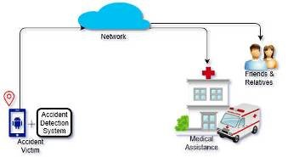

**Fig:2**

**3.2 Flow Chart**

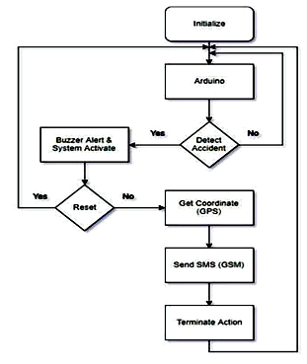

**Fig:3**

**3.3 Use Case Diagram**

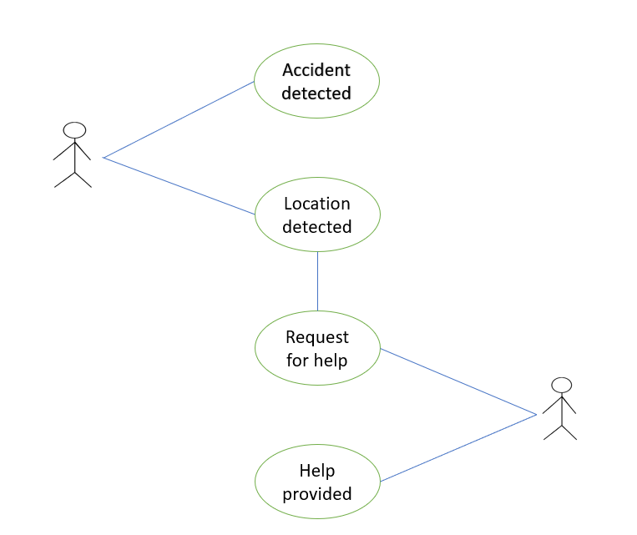

**Fig:4**

**CHAPTER 4**

**IMPLEMENTATION**

**4.1 Proposed Algorithm**

Step 1: Start

Step 2: Initialize all components:

* Set up GPS, GSM, accelerometer, buzzer, and LCD modules.
* Define threshold values for the accelerometer sensor.

Step 3: Continuously read sensor values from the accelerometer (X, Y, Z axes):

* If (sensor values < threshold values):
  + Keep monitoring the sensor values (return to Step 3).
* Else:
  + Go to Step 4.

Step 4: Retrieve GPS coordinates using the GPS module:

* If GPS data is valid:
  + Extract real-time latitude and longitude.

Step 5: Send accident information:

* Compose an SMS containing accident details, tilt direction, GPS coordinates, and Google Maps link.
* Send the SMS to a predefined emergency contact using the GSM module.

Step 6: Display the accident details on the LCD:

* Show accident status, tilt direction, latitude, and longitude on the LCD.

Step 7: Alert nearby emergency services:

* Assume help centre
* will contact the nearest hospital or rescue team using GPS data sent.

Step 8: Activate response:

* The help centre sends an ambulance or rescue team to the detected accident location.

**4.2 Code Used**

#include <Wire.h>

#include <TinyGPS++.h>

#include <SoftwareSerial.h>

#include <LiquidCrystal_I2C.h>

TinyGPSPlus gps;

SoftwareSerial gpsSerial(4, 5); // RX, TX

SoftwareSerial gsmSerial(2, 3); // RX, TX

LiquidCrystal_I2C lcd(0x27, 16, 2); // Change address to 0x27 if needed

const int buzzerPin = 9;

const int xPin = A0; // Connect X axis of GY-61 to A0

const int yPin = A1; // Connect Y axis of GY-61 to A1

const int zPin = A2; // Connect Z axis of GY-61 to A2

void setup() {

Serial.begin(9600);

gpsSerial.begin(9600);

gsmSerial.begin(9600);

lcd.init();

lcd.backlight();

lcd.clear();

lcd.setCursor(0, 0);

lcd.print("Accident Detection");

lcd.setCursor(0, 1);

lcd.print(" System ");

delay(3000);

pinMode(buzzerPin, OUTPUT);

String message="VEHICLE ACCIDENT DETECTION SYSTEM";

gsmSerial.print("AT+CMGF=1\r");

delay(100);

gsmSerial.print("AT+CMGS=\"9353821728\"\r"); // Replace with your phone number

delay(100);

gsmSerial.print(message);

delay(100);

gsmSerial.write(26);

delay(1000);

Serial.println("Message Sent: " + message);

}

void loop() {

while (gpsSerial.available() > 0) {

gps.encode(gpsSerial.read());

}

int x = analogRead(xPin);

int y = analogRead(yPin);

int z = analogRead(zPin);

Serial.print("X: "); Serial.println(x);

Serial.print("Y: "); Serial.println(y);

Serial.print("Z: "); Serial.println(z);

String position = "";

if (x > 400 || x < 300) {

digitalWrite(buzzerPin, HIGH); // Sound buzzer

if (x > 400) {

position = "Right Side";

} else {

position = "Left Side";

}

sendSMS(position);

displayParameters(position);

} else {

digitalWrite(buzzerPin, LOW); // Turn off buzzer

}

delay(1000); // Readings delay

}

void sendSMS(String position) {

String gpsLocation = "";

String googleMapLink = "";

if (gps.location.isValid()) {

gpsLocation = "Lat: " + String(gps.location.lat(), 6) + ", Lon: " + String(gps.location.lng(), 6);

googleMapLink = "http://maps.google.com/?q=" + String(gps.location.lat(), 6) + "," + String(gps.location.lng(), 6);

} else {

// Dummy location if GPS data is not available

gpsLocation = "Lat: 12.9716, Lon: 77.5946"; // Example coordinates (Bangalore)

googleMapLink = "http://maps.google.com/?q=12.5540321,75.3818573";

}

String message = "Accident Detected! Car Fallen on " + position + ". Location: " + gpsLocation + " Map: " + googleMapLink;

gsmSerial.print("AT+CMGF=1\r");

delay(100);

gsmSerial.print("AT+CMGS=\"9353821728\"\r"); // Replace with your phone number

delay(100);

gsmSerial.print(message);

delay(100);

gsmSerial.write(26);

delay(1000);

Serial.println("Message Sent: " + message);

}

void displayParameters(String position) {

lcd.clear();

lcd.setCursor(0, 0);

lcd.print("Accident Detected");

lcd.setCursor(0, 1);

lcd.print(position);

delay(2000);

lcd.clear();

lcd.setCursor(0, 0);

lcd.print("Latitude:");

lcd.setCursor(0, 1);

if (gps.location.isValid()) {

lcd.print(gps.location.lat(), 6);

} else {

lcd.print("12.9716"); // Dummy latitude

}

delay(2000);

lcd.clear();

lcd.setCursor(0, 0);

lcd.print("Longitude:");

lcd.setCursor(0, 1);

if (gps.location.isValid()) {

lcd.print(gps.location.lng(), 6);

} else {

lcd.print("77.5946"); // Dummy longitude

}

delay(2000);

}

**Chapter 5**

**Results and Discussion**

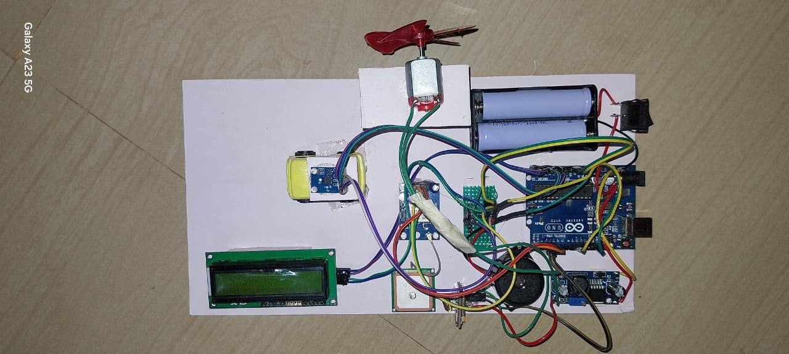

**Fig:5 Interfacing Arduino with all other module**

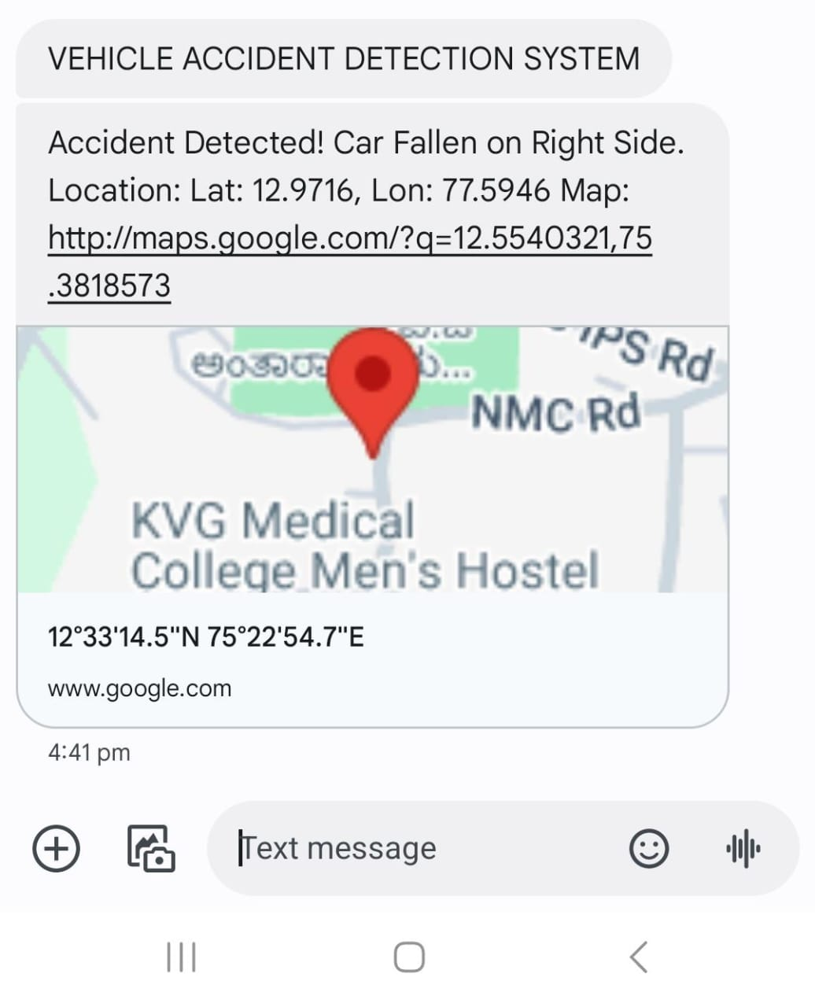

**Fig:6 Alert message**

**Chapter 7**

**CONCLUSION AND FUTURE SCOPE**

**7.1 Conclusion:**

The Automatic Accident Reporter project successfully demonstrates a reliable system for detecting and reporting vehicle accidents using GSM, GPS, and microcontroller technology. By providing real-time accident detection and immediate location reporting, the system significantly reduces response time, enhancing road safety. Its cost-effective design and scalability make it adaptable to various vehicle types, paving the way for future enhancements like IoT integration and advanced analytics for improved performance.

**7.2 Contribution:**

The Automatic Accident Reporter project contributes significantly to improving road safety through innovative use of technology. It enables real-time detection of vehicle accidents using sensor data, ensuring prompt identification of emergencies.

The system utilizes GSM and GPS modules to report the exact location of an accident to emergency contacts or authorities, reducing response times and potentially saving lives. Its cost-effective design, built with readily available components, makes it accessible for widespread implementation.

Additionally, the system is adaptable to various vehicle types, offering scalability for both personal and commercial applications. By integrating modern technology into accident detection, this project lays the groundwork for future advancements in emergency response systems.

**7.3 Future Scope:**

The Automatic Accident Reporter project has immense potential for future advancements to enhance its efficiency and functionality. Integrating the system with IoT platforms can enable centralized monitoring and real-time data analysis, making it more robust. Machine learning algorithms can be added to differentiate between minor incidents and severe accidents, improving the accuracy of emergency responses.

Upgrading communication technologies to 5G can ensure faster and more reliable data transmission in critical situations. The system can also include automatic notifications to nearby hospitals, ambulances, and police stations for quicker assistance.

Incorporating vehicle health monitoring features can provide valuable insights into vehicle conditions before and after accidents. Furthermore, integrating the system with smart city infrastructure will enable seamless coordination with traffic management and emergency services, making it a vital component of future urban mobility solutions.

**REFERENCES**

* 1. Md. Syedul Amin, Jubayer Jalil, M.B.I.Reaz, Accident Detection and Reporting System using GPS,GPRS and GSM Technology, IEEE,2012.
  2. Abdulrahman Taha Mohammed, Noor Ain Kamsani

*Department of Electrical and Electronics Engineering, Faculty of Engineering*

*Universiti Putra Malaysia*

* 1. Parag Parmar, Ashok M.Sapkal, Real time detection and reporting of vehicle collision, IEEE,2017.